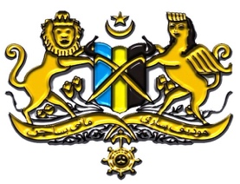

**Free Acheh Movement**

**Central Council**

March 23, 2024

Dear Prime Minister,

Our compliments to you and people of the Royal Kingdom of the Netherlands.

Since independence, the Netherlands and its people have prospered in many fields and are progressing further since joining the European Union. Democratically, the voice of the people are being attended to establish a stable and sound political environment, leading to economic, social and cultural development of the country.

This is very different from what is happening now in our land, Acheh, Sumatra.  We have become neo-colonial slaves in our own land when we should be masters, kings in the land of our own ancestors. We want to have a fair democracy like your own country. We want our country to prosper like yours.

Our country is ten times larger than the Netherlands; with plenty of natural resources and we really want to be able to trade civilly with you, as you have done with other independent countries. Now we have dried up our tears to cry, our eyes are too short-sighted to look, our energy has been exhausted after 81 years of Indonesian neo-colonialism. We believe that this will end with your open-hearted support as a former colonial power in the Dutch East Indies.

On March 23, 1873, the Dutch Government officially declared war on the Kingdom of Acheh-Sumatra. Our king was captured and exiled to the state of Batavia. Although we have lost our king, but our country is still intact, our ancestors defended our country tenaciously until more than a hundred thousand Achehnese died. Half a dozen of my own ancestors were killed at the hands of soldiers from your country. Even my grandfather, Tengku di Tiro Umar who was still 6 years old was also arrested and put in a juvenile prison in Bandar Acheh in 1910 on the same day his father Tengku di Tiro Mahjeddin who was the Head of State of Acheh at that time,  was killed by Dutch soldiers.

Paul Van't Veer once said:

"*The Dutch nation and the Dutch state have never faced a bigger war than the war with Acheh. According to the perspective of the time, this war can be called the eighty-year war. According to the number of victims - more than a hundred thousand people died - this war was one military event that has no comparison in the history of the Dutch nation. For the Dutch state and nation, the Acheh War was more than just a military dispute: for a century this was the main question of international politics, national politics, and Dutch colonial politics.*" (Paul Van't Veer, DE ATJEH-OORLOG, Amsterdam, 1969, p. 10).

"*Acheh is not Java. It is actually clear that in the part of the world that is generally an uncertainty called the Dutch East Indies ("Indonesia") there is no kingdom that can be compared to Acheh. This we know now. A war that lasted more than half-century, hundreds of thousands are dead, and half a billion of the expensive 19th century Dutch Rupiah, are proof of this. We know this now, but we did not know it in 1873. Let these statements stand. - don't hide it - so that people in the Netherlands, or more so on the island of Java, can know what kind of people the Achehnese are.*" (Paul Van't Veer, DE ATJEH OORLOG, p. 76)

The period of 'Indonesian' colonialism is longer than the Dutch colonialism in Acheh. We have been in the hands of 'Indonesian' neo-colonialism for 74 years. They have killed more than 150,000 thousand Achehnese people since 1976, if we go back to the previous years the number is far beyond what we know. This will continue with the murders that will come slowly. Our education has been greatly destroyed, our livelihood has disappeared, the life of our nation is far from what we call happiness. Our country is surrounded with military camps, our forests have been controlled illegally, our lands have become infertile with crops by being poisoned in various ways. Our nation breathes dust, because the roads have never been repaired properly and many other things in our lives are far below the adequate line of life.

As the descendant of Tengku Mahjeddin di Tiro, the Head of State of Acheh at that time, who was killed by your soldiers, I kindly seek your cooperation for ending the war in Acheh to sign a LETTER OF PEACE between our nations. The declaration of war on Acheh was never ended with the LETTER OF PEACE. That I am ready to sign on behalf of my Achehnese people and your government.

I remain,

Truly yours,

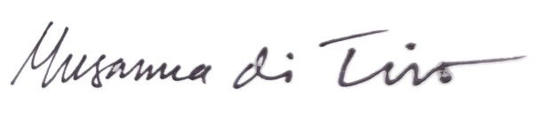

Tengku Musanna di Tiro

Head of the Free Acheh Movement

Central Council

Email: [musanna.tiro@freeacheh.org](mailto:musanna.tiro@freeacheh.org)

<http://www.freeacheh.org>

Embassy of the Kingdom of The Netherlands

4200 Linnean Ave NW

Washington DC 20008